Client Logos - Nonviolent Communication Training
Organizations that have received NVC training.
  Monks | 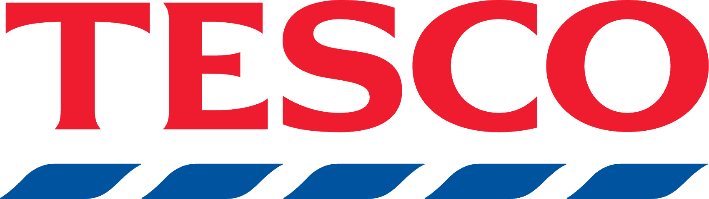  Tesco | 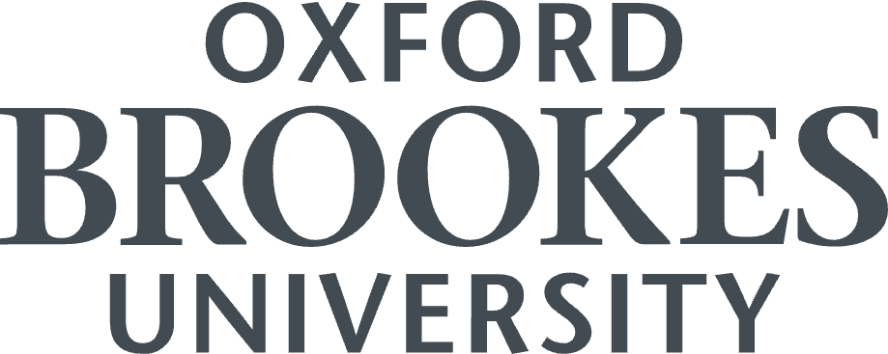  Oxford Brookes University
  Bank for International Settlements | 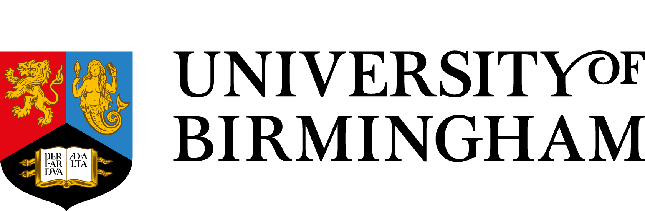  University of Birmingham Enterprise | 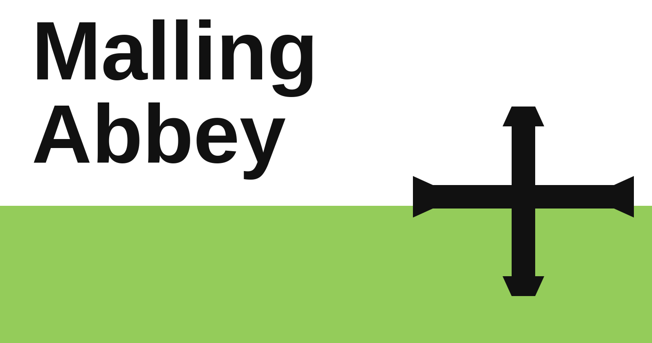  West Malling Abbey
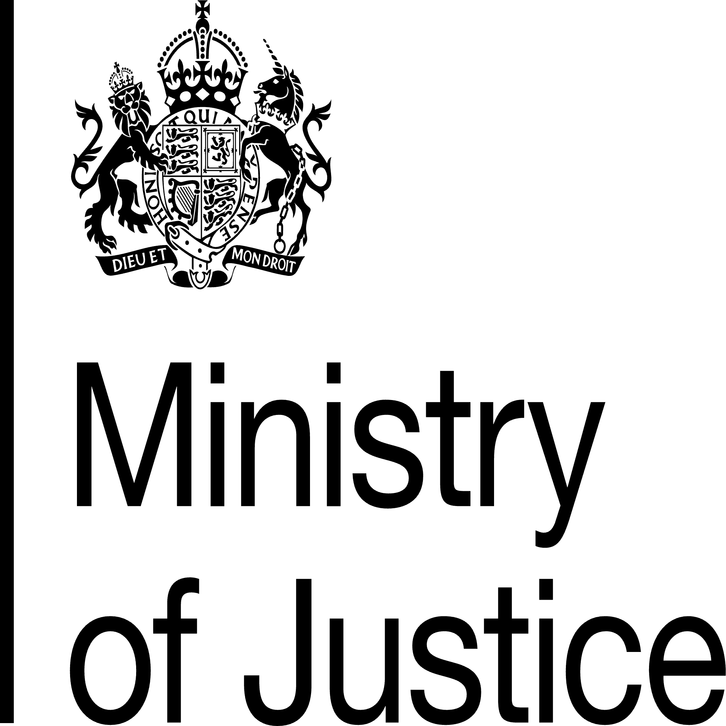  Ministry of Justice | 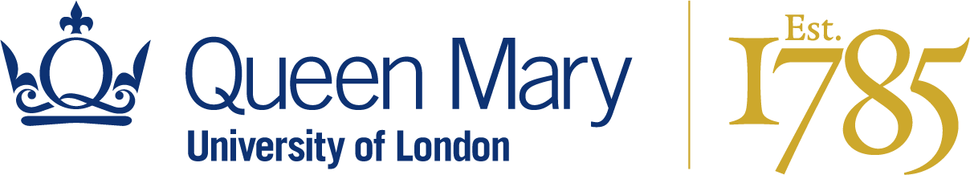  Queen Mary University of London | 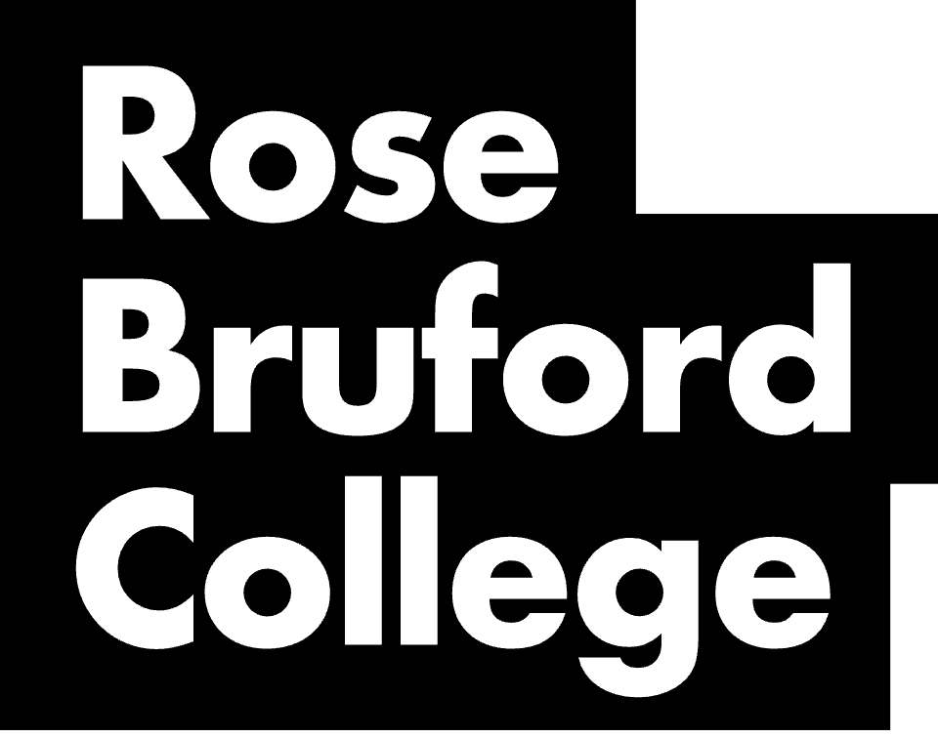  Rose Bruford College
  Ark Music (Ark Schools) |   Memrise | 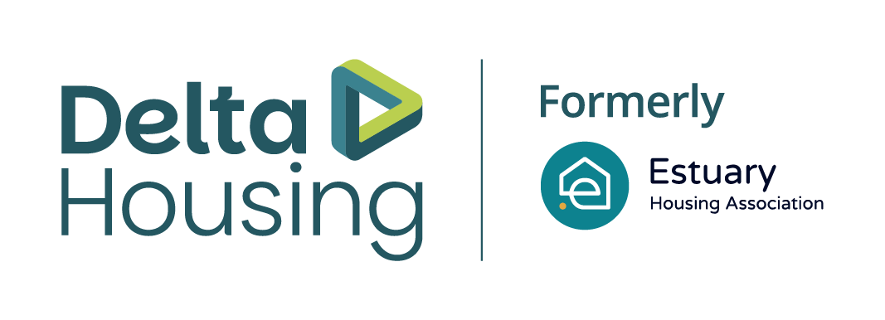  Estuary Housing
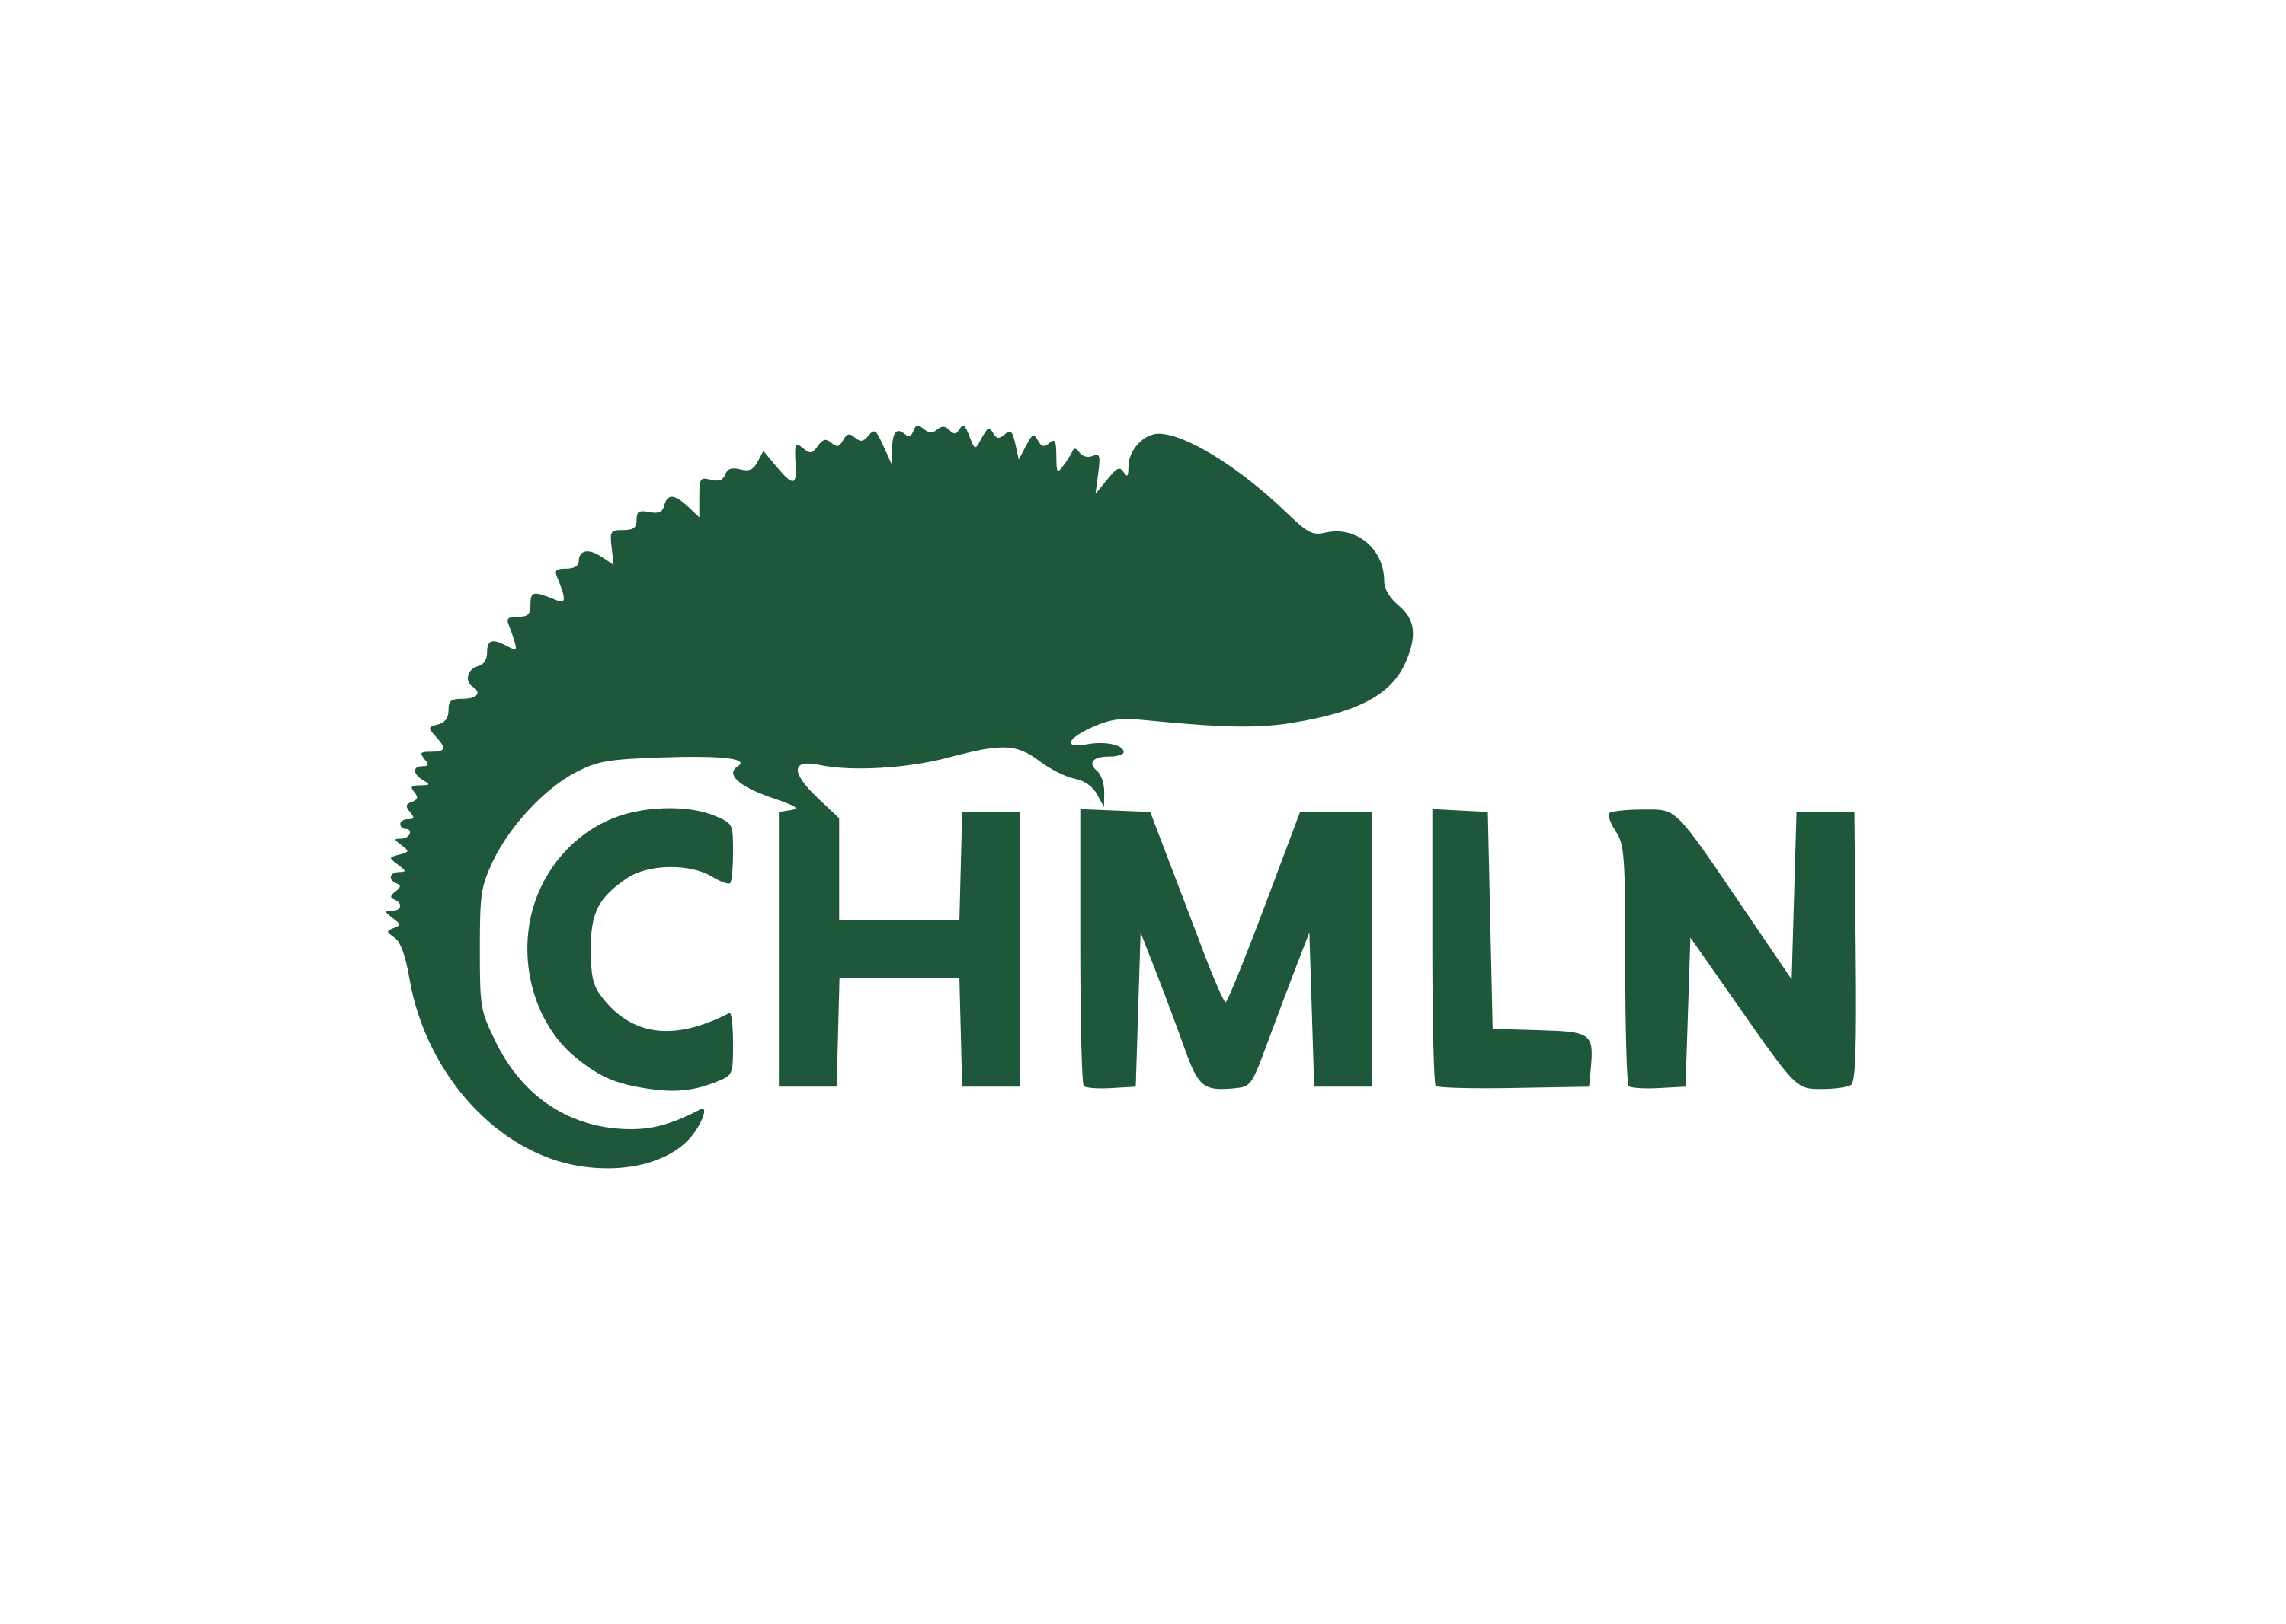  CHMLN |   Spiral Skills
Note: The West Malling Abbey and CHMLN logos were recreated as vector graphics from reference images (their official sites did not have downloadable logo files), matching the original colors and layout as closely as possible.

